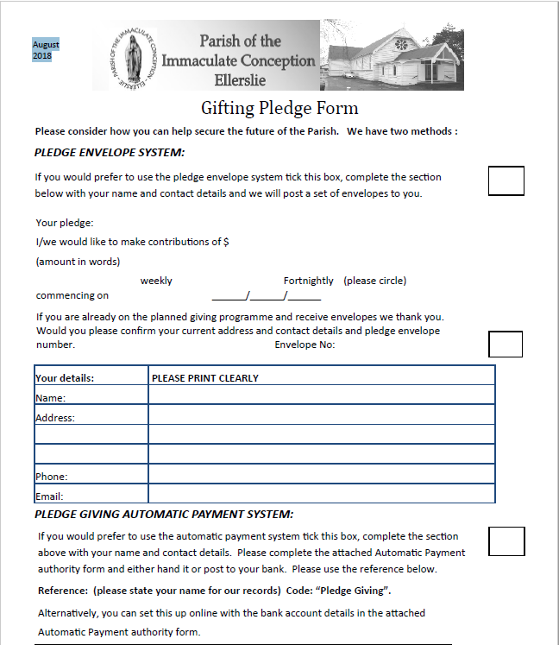
Bank Account Parish A/C: 02-0108-0706777-00 (BNZ)
Parish Priest: Fr. George Areeckal

66 Main Highway, Ellerslie
Email: icpellerslie@gmail.com
Phone: 09 579 5458
Website: www.ellersliecatholic.org.nz

